EC CHM Project
EUNIS 2 XLIFF User Guide



Modification history
Date | Version | Author | Reason for modification
15 Dec. 2005 | 1.0 | Daniel Chirca, Cristian Romanescu (Finsiel) | First version
Table of Contents
1 Introduction 4
1.1 Purpose of this document 4
1.2 Structure of this document 4
1.3 Field of application 4
1.4 Deviation from PMP 4
1.5 Reference and applicable documents 4
1.6 Terminology 5
1.6.1 Abbreviations, acronyms and definitions 5
1.6.2 Definitions 5
2 Tools description 7
2.1 EUNISXLIFF overview 7
2.2 Tool usage 7
2.3 XLIFF file format 8

Introduction

Purpose of this document
This document describes the usage of the additional tools shipped along with the EUNIS Database project.

Structure of this document
See Table of Contents.

Field of application
Contract | CWU Title | CWU Code
502009.4 | Data flow and data management | WU3

This document applies to the EUNIS EC CHM project.
The intended users are the analyst/programmers involved in EUNIS development and maintenance.

Deviation from PMP
N/a.

Reference and applicable documents
Code | Title | DATE
CHM-DW5-PMP-001 | Project Management Plan | 19 Feb 2003
CHM-DW3-DNC-001 | WU3 Dataflow and data management – Work order | 12 Feb 2003
CHM-DW5-PMP-002 | Production plan | 16 Jan 2003
CHM-DW3-CNT-001 | EUNIS Database with Sites | 03 Mar 2003
CHM-DW3-CNT-003 | EUNIS Database design | 10 Dec 2005
CHM-DW3-CNT-004 | EUNIS Database Tool Net – User Guide | 10 Dec 2005

Terminology

Abbreviations, acronyms and definitions
EC | European Commission
EUNIS | European Nature Information System
ETC/NPB | European Topic Centre / Nature Protection and Biodiversity
EDTN | EUNIS Database Tool NET
CHM | Clearing-House Mechanism
ROD | Reporting Obligations Database
MoE | Ministry of Environment
WU | Contractual Work Unit
EEA | European Environment Agency
EIONET | Environmental Information and Observation Network
IG | Interest Group (in CIRCA)
NFP | National Focal Point
SA1 | 1st Specific Agreement
SA2 | 2nd Specific Agreement
SA3 | 3rd Specific Agreement
SA4 | 4th Specific Agreement
PMP | Project Management Plan
N/a | Not applicable

Definitions
CIRCA or CIRCLE | The extranet tool developed under the IDA Programme and which constitutes the kernel of the EIONET system; CIRCLE is the name given to the tool in EIONET whereas CIRCA is the name of the tool to be used across Europe.
Interest Group | CIRCLE (i.e. CIRCA) is organised around Interest Groups i.e. a private workspace for a group of people that need to collaborate to achieve common objectives and tasks.
Interest Group Leader | In the context of CIRCLE, the Interest Group Leader is granted extended privileges to administrate manage and customise the Interest Group. S/he defines users and grant access rights within the Interest Group.

Tools description

EUNISXLIFF overview
EUNISXLIFF Tool represents the tool used to translate EUNIS web interface into other languages.
The tools is used to:
- Extract texts stored in the database and save them to an XLIFF XML compatible file;
- Import texts from a translated XLIFF XML file back into database as another language.

Tool usage
Tool will be configured using the configuration file named settings.properties. Below is an example of the configuration file with lines number.
1.mysql.url=jdbc:mysql://dvd-rw:3306/eunis2?autoReconnect=true&useUnicode=true&characterEncoding=utf8
2.mysql.user=charlie
3.mysql.password=letmein
4.mysql.catalog.select=select a.* from `eunis_web_content` as a, (select max(record_date) mx,id_page,lang from `eunis_web_content` group by id_page,lang) as b where a.id_page = b.id_page and a.lang = b.lang and a.record_date = b.mx and a.lang=? and concat(a.record_date)<>'0000-00-00 00:00:00'
5.mysql.catalog.select.invalidonly=select a.* from `eunis_web_content` as a, (select max(record_date) mx,id_page,lang from `eunis_web_content` group by id_page,lang) as b where a.id_page = b.id_page and a.lang = b.lang and a.record_date = b.mx and a.lang=? and concat(a.record_date)<>'0000-00-00 00:00:00' and content_valid=0
6.mysql.catalog.insert=INSERT INTO EUNIS_WEB_CONTENT( ID_PAGE, CONTENT, LANG, RECORD_AUTHOR ) VALUES( ?, ?, ?, 'EUNISXLIFF' );
7.extractinvalidonly=false
8.operation=export
9.xliff.filename=test.xliff

10.xliff.sourcelanguage=en
11.xliff.targetlanguage=dk
The format of the file is VARIABLE=VALUE so the next section will explain each variable from the configuration file.
mysql.url – Database connection URL. That is where EUNIS database resides and where it’s tables with web content is located.
mysql.user – Username that has access to the database
mysql.password – Password associated with username
mysql.catalog.select – Used to select the latest versions of the text from the database. Users should not normally need nto modify this string.
mysql.catalog.select.invalidonly - Used to select the latest invalid versions of the text from the database. Users should not normally need nto modify this string.
Invalid records are those records which were modified since application installation. For example if someone modified a text within application that text will be marked as invalid (modified). The export tool implements this flag, to export only modified records.
mysql.catalog.insert – SQL Insert used to put the imported keys into the database.
extractinvalidonly – Specifies that only the invalid texts (texts that have been modified since original installation) will be exported from the database. Valid (original) texts will not be exported to the final xliff xml file. Parameter has two possible values: false – export all the data and true – export only items marked as invalid.
operation – Specifies the direction of the operation. Have two possible values: import – import from xliff file into the database and export – export from database to file.
xliff.filename – Name of the xliff xml file. If the operation is import that file must exists on the disk and contain valid translation. If the operation is export, that file will contain the texts to be translated.

The XLIFF toll will be executed by running the ‘eunisxliff.bat’ under Windows or ‘eunisxliff.sh’ under Linux.

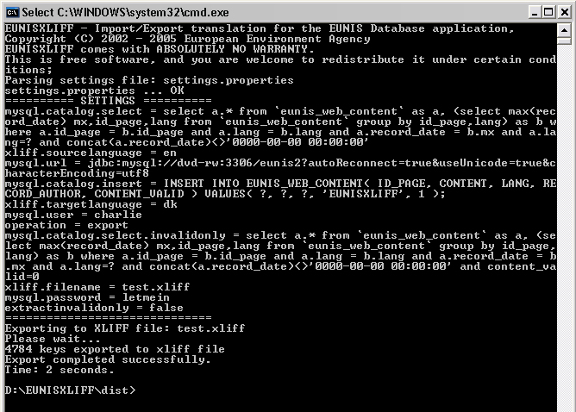

XLIFF file format
XLIFF file format is derived from the XML file format and it becamed an international standard used to translate resources from/into different languages.
XLIFF has been developed by Organization for the Advancement of Structured Information Standards (OASIS). An more in depth specification of XLIFF file format can be found at the consortium website: http://www.oasis-open.org.

Below is a sample of an basic XLIFF file containing two entries.
<?xml version="1.0" encoding="UTF-8"?>
<xliff version="1.0">
<file
original="/databasedump.txt"
product-name="EUNISXLIFF"
product-version="0.1"
datatype="plaintext"
source-language="en"
target-language="ro"
date="Thu Dec 08 16:57:37 EET 2005">
<header></header>
<body>
<trans-unit id="abbreviation">
<source>Abbreviation</source>
<target>Abreviere</target>
</trans-unit>
<trans-unit id="about_EUNIS_database">
<source>About EUNIS Database</source>
<target>Despre baza de date EUNIS</target>
</trans-unit>
</body>
</file>
</xliff>
This is the format exported from the EUNIS database, and the format expected while importing.
trans-unit represents a unit of translation. He has an attribute named id containing a unique key among all resource keys from the file, identifying that specific resource. That key should never change. Each trans-unit contains two tags: source and target. source represents the source in the default language and target represents the translated resource within specified language.

file tag represents the delimiter for the entire xliff file. Here must be mentioned two important attributes: source-language and target-language. source-language is the language for the text contained within source tag and target-language is the language the text will be translated in.

